# 

School of Geography, Geology and the Environment Vers. 2022. final

# Guidelines on the undertaking of a Master’s Thesis

These guidelines are applicable to all Master of Science (MSc) programmes operating in SGGE. Whilst every attempt has been made to ensure the instructions are consistent for students on these programmes, if you do have any questions, please contact the School Office (**geogadmin@le.ac.uk**) or the module convenor Dr Nick Tate (**njt9@le.ac.uk**). Please note that progression to the dissertation/thesis component is dependent on achieving the progression requirements according to Senate Regulation 6.

## The Research Project

Now that your project is underway and your proposal has been deemed to have passed you will have to work with your supervisor to establish a baseline of administration that includes the completion of any ethical/health and safety considerations and a set of project milestones or achievements that you need to manage. Fundamentally, this involves a set of decisions related to any further targeted reading and preparatory work required, data collection, data analysis, forming and writing it all up. Your research aim/questions/objectives will provide the framework to guide you. Your project risk register submitted as part of your proposal is a live document that will also help you to make decisions and provide discussion points in supervision meetings. Your project timetable, visualised as a GANTT chart in your proposal, is also a live document and should be updated on a regular basis.

### 1.1 Supervision and meetings

You have been allocated a supervisor to help you to deliver your research thesis. A minimum of five meetings are required (one a month), with the focus of each listed below (forms, deadline dates and where to submit are available at the end of this document):

**Meeting 1** Review written feedback from your proposal/research plan refinement, progress ethical approval form, health and safety. Review GANTT Chart and risk register (if required – your supervisor may insist). Agree actions/next steps to take forward, incl. date of next meeting.

**Meeting 2** Review research progress, sign off (if not done already) of any health and safety forms. Discuss any on-going ethical issues (if appropriate). Review GANTT Chart and risk register (if required). Agree actions/next steps to take forward incl. date of next meeting.

**Meeting 3** Review progress on the method(s) and data acquisition plus research results. Review GANTT Chart and risk register (if required). Agree actions/next steps to take forward incl. date of next meeting.

**Meeting 4** Review research results in relation to research questions (or specific objectives if more appropriate). Consider thesis structure and writing plan. Review GANTT Chart and risk register (if required). Target a date for draft chapter submission to supervisor. Agree actions/next steps to take forward incl. date of next meeting.

**Meeting 5** Feedback on draft chapter from supervisor, consider writing progress. Agree actions/next steps to take forward to date of submission.

It is **YOUR** responsibility to arrange and attend these meetings with your thesis supervisor and to liaise with your supervisor throughout the period of time allocated to the thesis. These meetings **MUST** be documented using the forms provided on Blackboard. Both you and your supervisor should electronically sign the form to confirm that supervisory meetings have taken place, and **YOU must upload the form no later than 48hrs of the deadline.** *Note the dates mentioned on the forms are* ***deadlines****: you may wish to hold your meetings in advance of these dates.*

If you have any concerns over the level of supervision you are receiving, then first talk to your supervisor. If your concerns still remain, please contact Dr. Nick Tate (**njt9@le.ac.uk**).

### 1.2 Planning for the summer

Find out in advance at what times during the summer your supervisor is available to provide any support, feedback or advice and how they can be contacted. Be aware that your supervisor will be taking their holidays and certainly conducting his/her own research activities during this period. In other words, you must forward plan accordingly, particularly with respect to scheduled meetings. One suggestion is to try and put all agreed meeting dates into the diary as soon as possible. *Contact* Dr Nick Tate (**njt9@le.ac.uk***) if your supervisor appears unavailable outside of planned absences*.

### 1.3 Reading your thesis

Supervisors are not expected to proof read your thesis or provide substantive comments/corrections on English language, grammar or structure. University guidance on the use of proof readers can be found here <https://le.ac.uk/policies/research/proof-reading>. Your supervisor is available to comment on ONE draft of ONE chapter of your thesis **PROVIDING THAT YOU ALLOW THEM SUFFICENT TIME TO DO SO.** It is your responsibility to make sure that you allow them sufficient time to read it and to feed their comments back to you. You have to decide which chapter you will ask them to review, but I would suggest the ‘ideal’ choice is your results chapter.

## Format Regulations for the Submission of a Master’s Thesis in SGGE

The thesis is presented as a scientific/social science report with appropriate references to the literature, and should be **15,000** words in length maximum. The word count does not include words in the references, table of contents, list of tables, list of figures and appendices. Figure and table captions however **DO** count. *Standard SGGE penalties will apply for anyone writing a piece that does not fall within these boundaries*.

Please talk to your supervisor about how you might best structure the content in your dissertation. There are many different formats from the more traditional (e.g., introduction, literature review, methods, results and conclusions sections) to non-traditional structures more used in social science. You should use the Harvard system of citation and referencing.

Also talk to your supervisor about the nature of material and that might be appropriate for including as an Appendix. Examiners will look at the material presented in Appendices and whilst there is no specific grade or mark for this part of the report, supplementary information presented here may help the examiner to better understand other components of the work.

Your thesis should have the following format:

1. Any Accessibility related cover sheet attached to the start of your document
2. Title Page to include, as well as the full title of the dissertation, the degree for which the work is submitted, the year of submission, your full name and a statement that you certify that this is your own original work. *Please use the template title page included below as part of these guidelines, though omit the page number.*
3. An abstract of around 250 words that must be presented on a single page of A4.
4. Acknowledgements page.
5. Table of Contents, List of Figures, List of Tables, Lists of Acronyms/Abbreviations/Symbols (if used).
6. Main body of thesis in size A4 (unless maps etc. are better presented in the PDF on A3 page size) with 12 point Calibri for body text; 1.5 line spacing and 25 mm margins minimum all around.
7. Text to include page numbers in Roman numerals (i,ii,iii,iv etc) for (5) above and then ‘normal’ numbers (1,2,3,4 etc) from the first page of the main body of the thesis (ie. Chapter 1, page 1) onwards.
8. Appendices (if used)
9. References



**TITLE**

**By**

**Your full name**

**2022**

**In submitting this thesis, I confirm that it is my own work.**

**A thesis submitted to the School of Geography, Geology and the Environment, University of Leicester in partial fulfilment of the requirements for the degree of Master of Science**

## Submission Deadline and Late Submission Penalties

Please submit your thesis on Blackboard via Turnitinon or before:

**11am on Friday 30th September 2022**.

**Important: You will need to have a completed submission of 5 meetings on Blackboard as well.**

Requests for mitigating circumstances to be taken into account will only be granted on the grounds of medical evidence or significant personal circumstances and should be submitted before the work is due. In all other cases, late submission penalties will be strictly applied. *If submission occurs late, then the student’s work may not be considered until the following Exam Award Board and you will not graduate until January 2024.*

## Assessment Process and Feedback

For MSc students taking GY7720, your thesis is worth 95% of the module mark, the other 5% coming from the research proposal. For MSc students taking GY7420, your thesis is worth 100% of the module mark.

The thesis will be assessed independently by two internal examiners, normally your supervisor and one other member of staff.

Your supervisor will prepare a report on the thesis, as part of his or her evaluation as a marker. This refers to the scheme of assessment that is in the PGT handbook and is reproduced at the end of this document. They will also comment on:

a) The amount of help and supervision given to and needed by the student in the collection of data;

b) The amount of help given to the student in writing the dissertation.

The second marker will also comment on the dissertation and mark it.

If the difference between the mark of the first and second marker is 5% or less and within the same degree classification the marks simply get averaged. If the difference between the marks is between 5-20% or crosses a degree class boundary then the two markers will meet to agree a mark. If the markers cannot agree then the work will be marked blind by a third marker. In the rare case that the marks of the first and second markers differ by more than 20% then the dissertation will automatically be sent to be blind marked by a third marker. For cases involving three markers, all markers will meet to agree a mark. If the three markers cannot agree, then the mark will be decided by the PGT Director/Module convenor in consultation with colleagues as appropriate. As with all marks, Dissertation marks are provisional until confirmed by the Board of Examiners.

After the examination board has met in November 2022, you will receive feedback by email on your dissertation performance.

### 4.1 Contact details

It is ABSOLUTELY VITAL that your contact details on MyStudentRecord are up to date so that you can be contacted with information on graduation.

**Nick Tate**

**May 2022**

**Meeting forms overleaf. Please USE the editable versions on blackboard.**

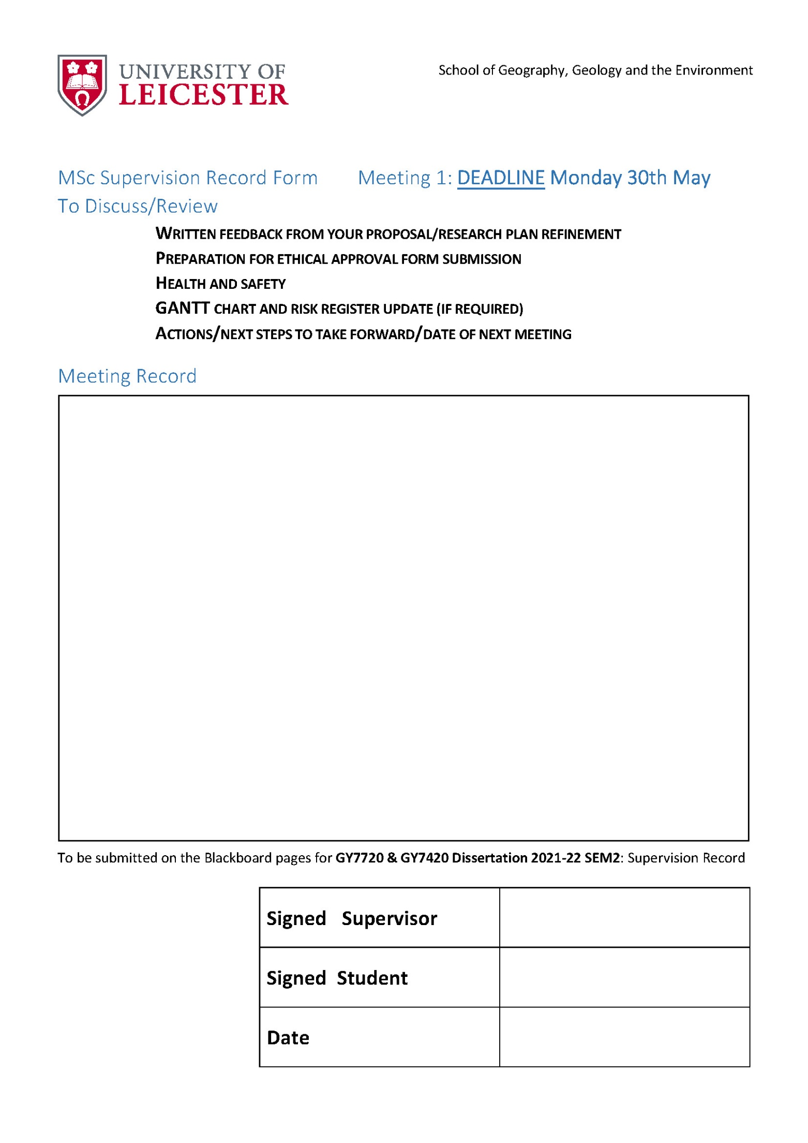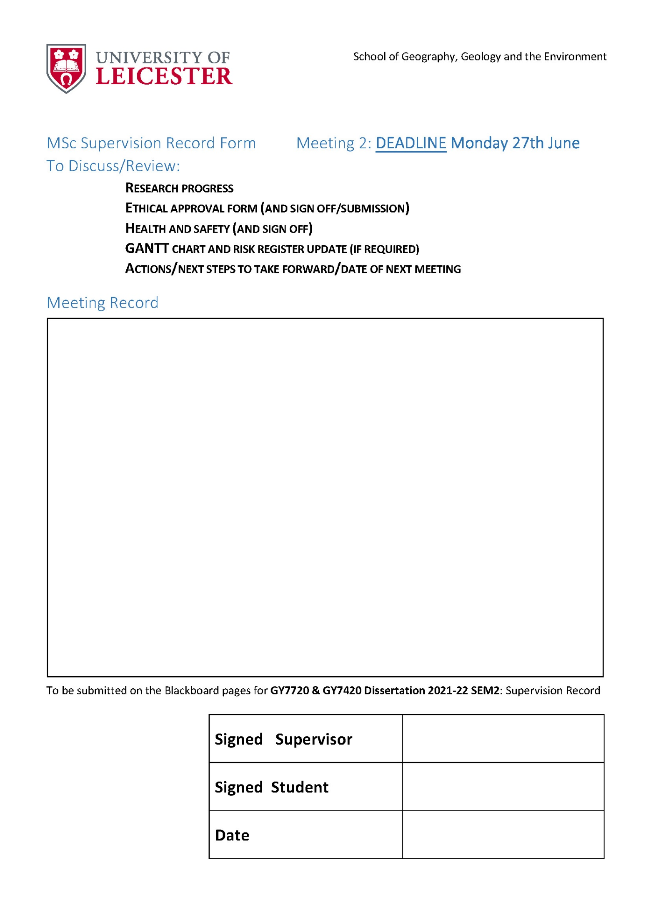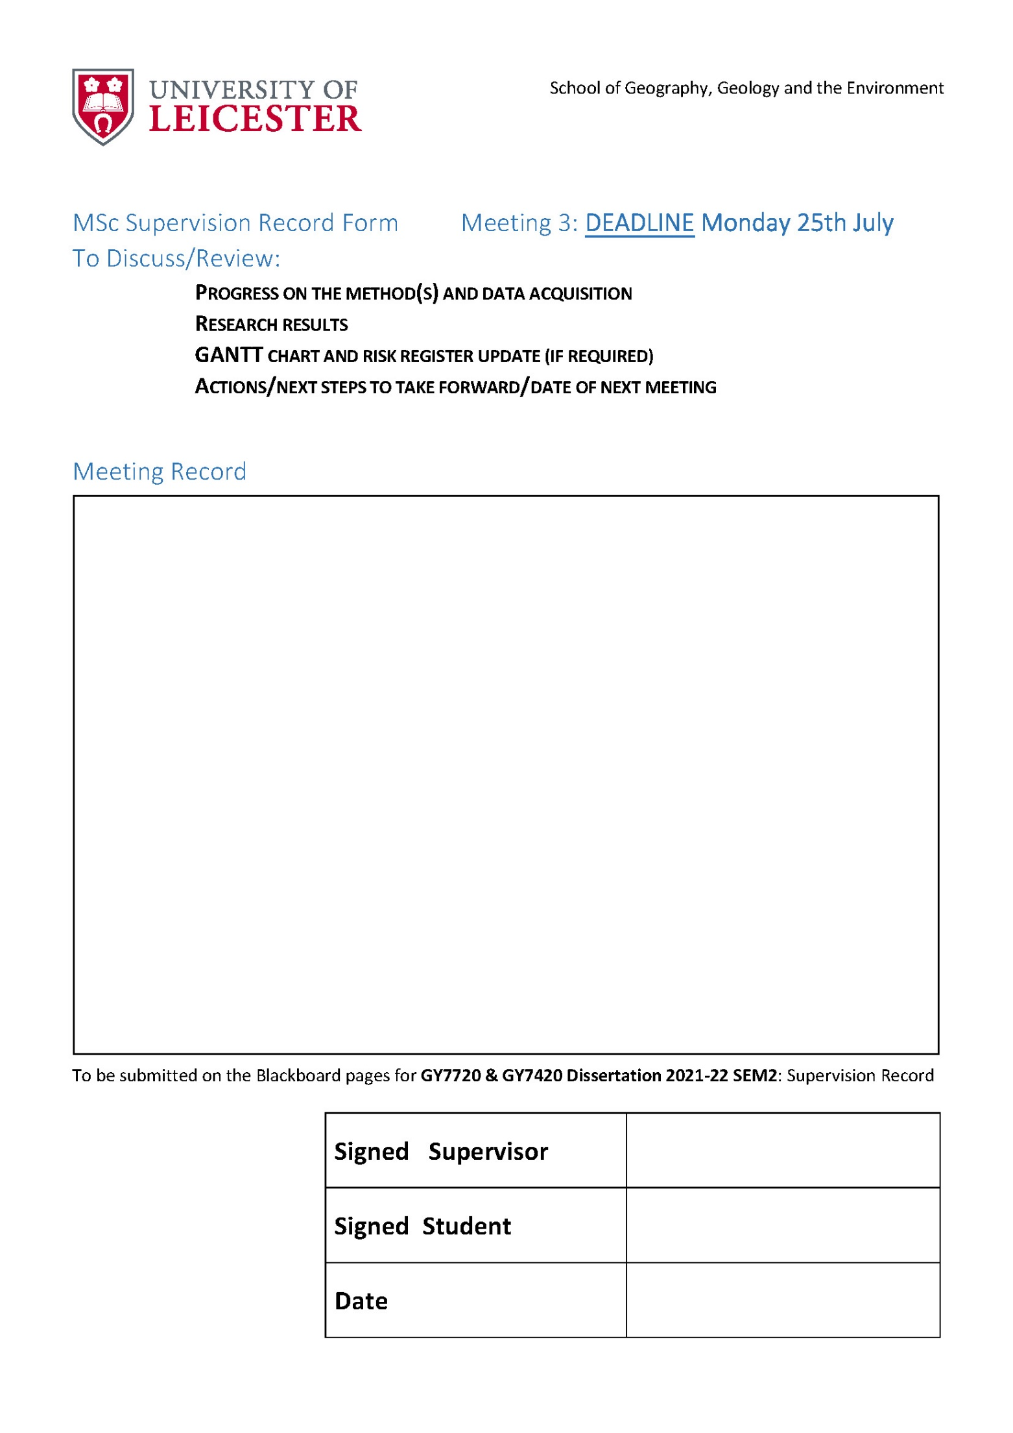

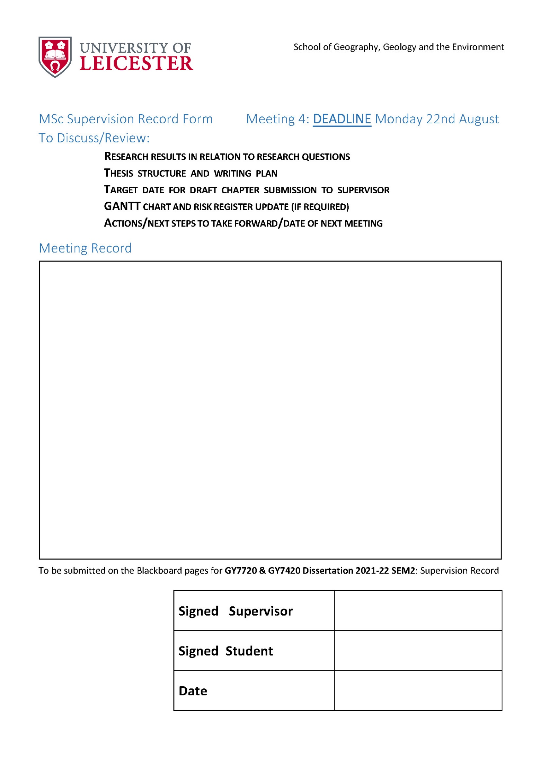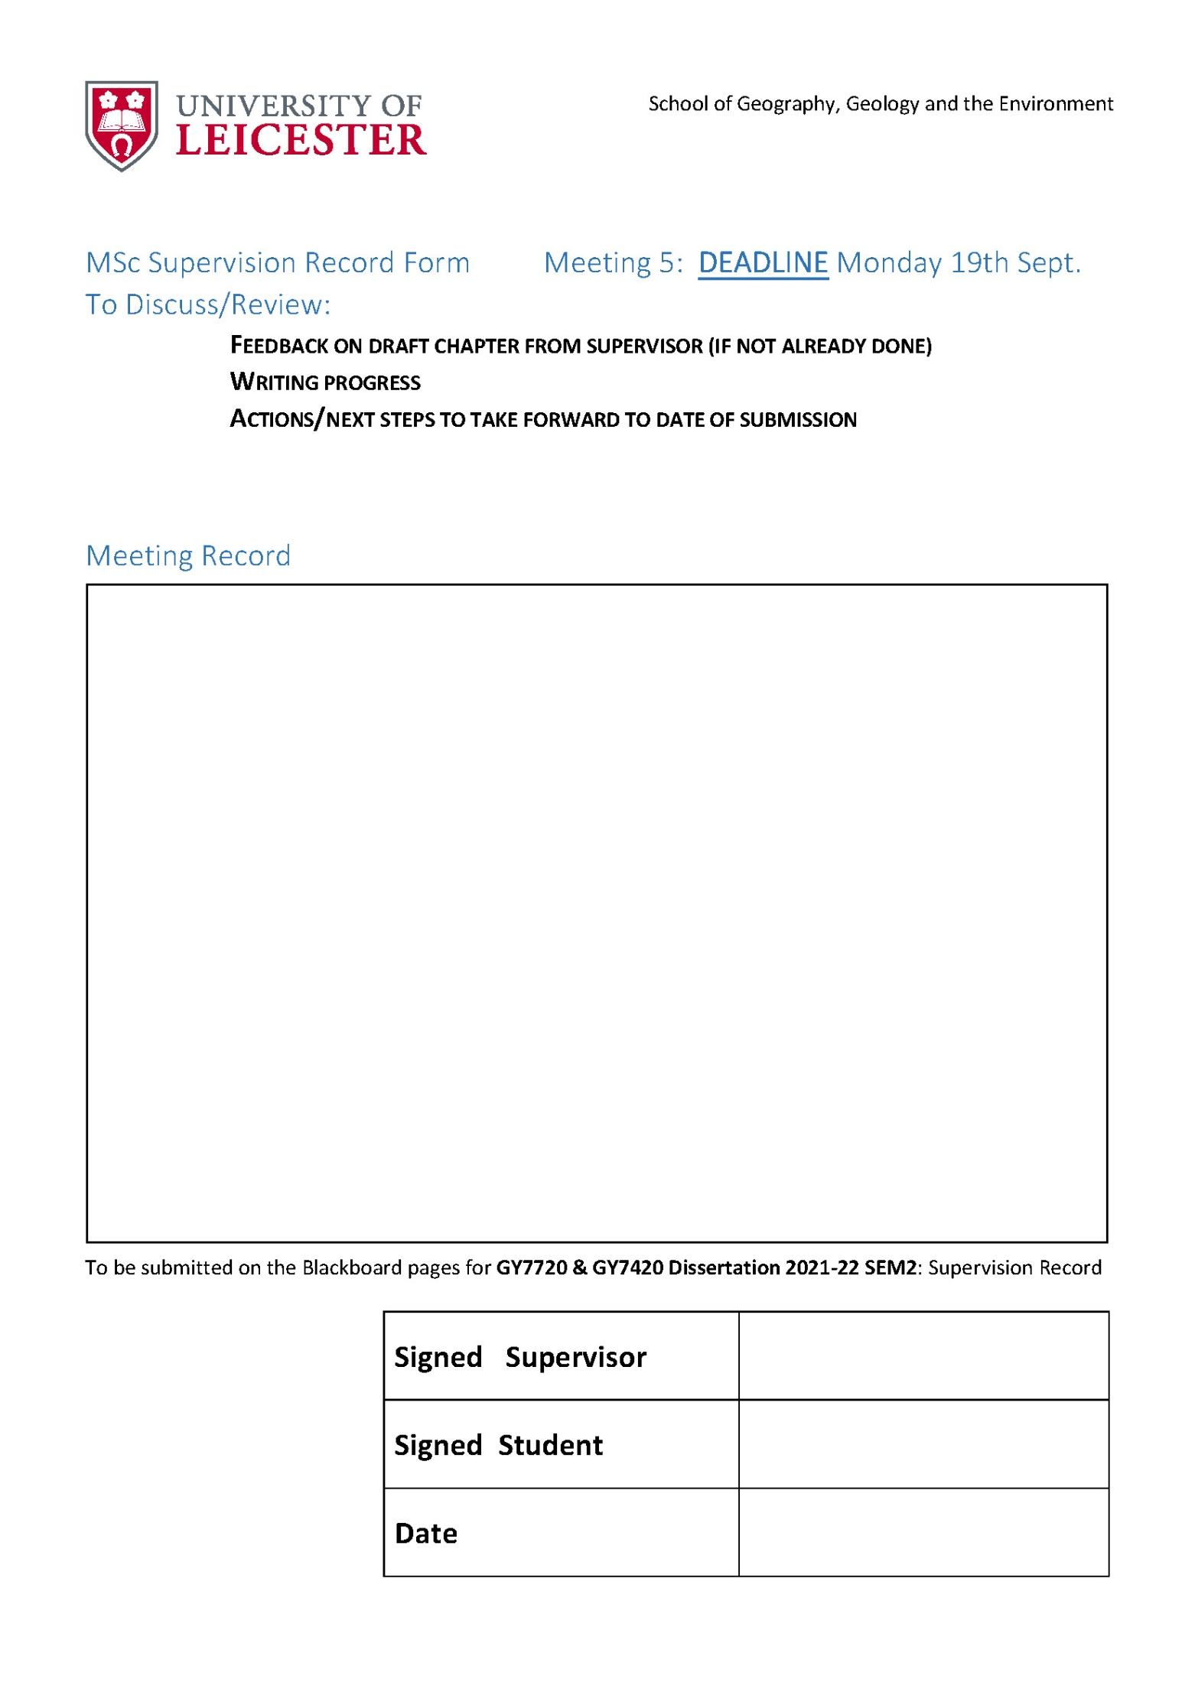

**Dissertation marking form overleaf**

